Page 1

**Capstone Project**

**Assignment 1**

Course code: CSA1643

Course: Data Warehousing and Data Mining for data science

S. No: 05

Name: B. V. N. S. Gowrinadh

Reg. No: 192211043

Slot: C

Title: **Traffic congestion prediction and management for data warehousing**

Assignment Release Date:

Assignment Preliminary Stage (Assignment 1 ) submission Date :

Mentor Name: Dr. M. Prabhaharan

Mentor Phone number and Department: 9444717580 and condensed matter physics

**1. Preliminary Stage**

**1.1 Assignment Description:**

**Description of the Project**: Our project focuses on utilizing data warehousing techniques for predicting and managing traffic congestion in urban areas. By analysing vast amounts of traffic data, we aim to develop insights and strategies to alleviate congestion and improve transportation efficiency, ultimately enhancing urban mobility and liability.

**1.2 Assignment Work Distribution:**

**Project Scope Definition:0**

**Define the scope and objectives of the project:** Our project aims to analyse historical traffic data to predict future congestion patterns and implement effective management strategies.

**Specific goals of analysing**: We aim to identify peak traffic hours, congestion hotspots, and factors contributing to traffic congestion.

**Data Collection and Preparation:**

**Identify the data sources:** We will gather traffic data from sources such as traffic cameras, GPS tracking devices, and traffic management systems. Determine the sources of data needed for congestion prediction, such as traffic sensors, GPS data, weather reports, road infrastructure information, and historical traffic patterns. Set up mechanisms to collect data from the identified sources in real-time or near real-time. This may involve integrating with APIs, deploying IoT sensors, or accessing public datasets.

**Develop a data collection plan:** Our plan includes collecting real-time and historical traffic data from various sources and integrating it into a centralized data warehouse. Set up mechanisms to collect data from the identified sources in real-time or near real-time. This may involve integrating with APIs, deploying IoT sensors, or accessing public datasets. Identify relevant features or variables that influence traffic congestion, such as traffic volume, road conditions, weather conditions, time of day, and special events. Select a subset of informative features for modelling and analysis.

**Cleanse and preprocess the collected data to ensure data quality:** We will perform data cleaning techniques such as removing duplicates, handling missing values, and standardizing data formats to ensure accuracy and consistency. Cleanse the collected data to remove inconsistencies, errors, and missing values. Perform preprocessing tasks like data normalization, standardization, and feature engineering to prepare the data for analysis. Document the data collection and preparation process, including metadata such as data sources, transformations, and schema definitions. Maintain metadata catalogues for easy reference and tracking of data lineage.

**Consistency of the project:** Ensuring data consistency across different sources and time periods is crucial for accurate analysis and prediction. Implement quality assurance measures to ensure the accuracy, reliability, and consistency of the prepared data. Perform data validation, error detection, and outlier detection to maintain data integrity. Manage temporal aspects of the data, such as timestamps and time intervals, to capture temporal patterns and trends in traffic congestion.

**Exploratory Data Analysis (EDA):**

**Conduct exploratory data analysis:** We will explore the traffic data to understand patterns, trends, and anomalies. Gather relevant data sources including traffic flow, road conditions, weather data, and any other factors that may influence traffic congestion. Combine data from different sources into a single dataset. This may involve merging datasets based on common identifiers or spatial/temporal relationships. Visualize the data using plots, charts, and maps to identify patterns, trends, and correlations. This can include time series plots of traffic flow, histograms of congestion levels, and geographical maps of traffic hotspots.

**Understand the patterns and trends:** Analysing traffic flow, congestion levels, and spatial-temporal variations will help identify underlying patterns and trends.

Build predictive models using machine learning techniques such as regression, classification, or time series forecasting.

Train the models on historical data and evaluate their performance using metrics such as accuracy, precision, and recall.

Perform descriptive statistics, such as summary statistics, distribution plots, and correlation analysis, to explore the relationships of the data: We will use statistical techniques to gain insights into traffic patterns and correlations between different variables.

Visualize the data using charts, graphs: Visualizations such as line charts, heatmaps, and scatter plots will help visualize traffic patterns and trends.

**2. Problem Statement**

Traffic congestion is a significant issue in urban areas, leading to increased travel time, pollution, and economic losses.

The lack of efficient management strategies exacerbates congestion problems, impacting the quality of life for residents and hindering economic development.

Therefore, there is a critical need for effective solutions to predict and manage traffic congestion using data-driven approaches.

Traffic congestion is a persistent issue in urban areas, leading to increased travel times, fuel consumption, and environmental pollution.

Current traffic management systems often rely on limited data sources and reactive strategies, resulting in suboptimal solutions.

To address this challenge, there is a need for a comprehensive approach that leverages data warehousing techniques to integrate diverse data sources and enable proactive traffic congestion prediction and management.

This research aims to develop a robust system capable of accurately predicting traffic congestion levels and implementing effective management strategies in real-time, ultimately improving transportation efficiency and reducing congestion-related issues in urban environments.

**3. Abstract**

Our project aims to address the problem of traffic congestion in urban areas by leveraging data warehousing techniques for predictive analytics and management.

Through the analysis of historical traffic data, we seek to develop insights into traffic patterns, identify congestion hotspots, and implement proactive measures to alleviate congestion.

By integrating real-time traffic data into a centralized data warehouse, we aim to create a comprehensive platform for monitoring and managing traffic flow efficiently.

The results of our project have the potential to significantly improve urban mobility, reduce travel time, and enhance the overall quality of life for city residents.

Traffic congestion poses significant challenges for urban areas, leading to increased travel times, fuel consumption, and environmental pollution.

To address this issue, this study proposes a novel approach for traffic congestion prediction and management leveraging data warehousing techniques.

The proposed system integrates real-time traffic data, historical traffic patterns, weather conditions, and other relevant factors into a comprehensive data warehouse. Machine learning algorithms are then employed to analyse and predict traffic congestion levels accurately.

Additionally, advanced analytics techniques are utilized to optimize traffic management strategies, including dynamic routing, signal timing adjustments, and public transportation scheduling.

The effectiveness of the proposed approach is evaluated through extensive simulations and case studies, demonstrating its ability to significantly reduce traffic congestion and improve overall transportation efficiency in urban environments.

This research contributes to the development of intelligent transportation systems capable of proactively managing traffic congestion and enhancing the quality of life for urban residents.

**4. Proposed Design Work**

**Identify the key components:**

**Functionality:** The system will include modules for data collection, preprocessing, predictive modelling, and traffic management. Set up monitoring tools and automated alerts to detect system anomalies and performance issues. Establish regular maintenance routines for data quality assurance, system updates, and optimization. Implement robust security measures to protect sensitive traffic data and ensure compliance with privacy regulations. Use encryption, access controls, and data anonymization techniques to safeguard data integrity and confidentiality. Collect real-time traffic data from various sources such as sensors, cameras, GPS devices, and traffic management centres. Gather historical traffic data to analyse trends and patterns. Integrate data from multiple sources into the data warehouse, ensuring consistency and accuracy. Cleanse and preprocess the data to remove duplicates, errors, and inconsistencies.

Store the integrated data in a structured format within the data warehouse, optimized for querying and analysis. Implement appropriate data partitioning and indexing strategies to optimize data retrieval performance.

Develop machine learning models to predict traffic congestion based on historical and real-time data. Utilize algorithms such as regression, time series analysis, and neural networks to forecast traffic conditions. Continuously update and refine prediction models based on new data and feedback.

**Architectural Design:** The architecture will consist of a centralized data warehouse, analytics engine, and user interface for visualization and decision-making. Develop data models and analytical algorithms to extract insights from the stored data.

Use techniques like machine learning, statistical analysis, and predictive modelling to predict traffic congestion patterns. Ensure scalability and performance by designing the system to handle peak traffic loads and accommodate future growth. Utilize cloud-based infrastructure and horizontal scaling techniques for elasticity and resilience.

Implement robust security measures to protect sensitive traffic data and ensure compliance with privacy regulations.

Use encryption, access controls, and data anonymization techniques to safeguard data integrity and confidentiality.

Design intuitive dashboards and reporting tools to visualize congestion predictions, traffic trends, and recommended actions.

Provide interactive maps, charts, and alerts to assist traffic managers and users in making informed decisions.

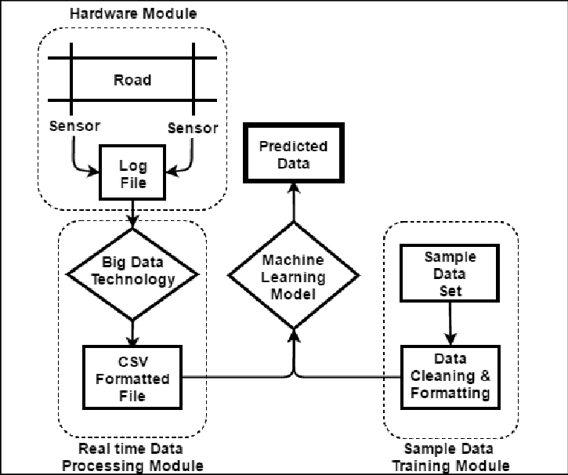

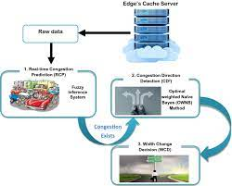

**5. UI Design**

**Layout Design**: The user interface will feature intuitive navigation, with dashboards and interactive maps for visualizing traffic data. Store the collected data in a centralized repository for analysis and processing. Utilize algorithms and machine learning models to analyse historical and real-time data to predict congestion patterns. Create a user-friendly dashboard to visualize congestion levels, predict future congestion, and suggest optimal routes or management strategies.

**Flexible Layout:** The layout will be adaptable to different screen sizes and devices for accessibility and usability.

Create a user-friendly dashboard to visualize congestion levels, predict future congestion, and suggest optimal routes or management strategies.

Provide an overview of key metrics such as traffic volume, congestion levels, average speeds, and incidents. Include visualizations like charts, graphs, and maps to present data in a clear and intuitive manner.

**User-Friendly:** The interface will prioritize user experience, with simple and intuitive controls for data exploration and analysis. Implement alerts or notifications for traffic authorities or drivers based on predicted congestion levels.

Display real-time and historical data on traffic congestion levels. Provide an overview of key metrics such as traffic volume, congestion levels, average speeds, and incidents.

Include visualizations like charts, graphs, and maps to present data in a clear and intuitive manner.

**Colour Selection**: Colour schemes will be chosen to enhance readability and convey information effectively. Use a light green colour to represent areas with low traffic congestion.

This colour signifies smooth traffic flow. opt for a yellow colour for moderate congestion levels.

Yellow indicates caution and serves as a warning sign for increasing traffic density. Choose a red colour for high congestion areas.

Red signifies stop or high alert, indicating heavy traffic congestion.

Ensure that the colours chosen to provide clear differentiation between different levels of congestion to aid in quick interpretation of the data.

Consider colourblind-friendly options to ensure inclusivity in the visualization.

Maintain consistency in colour usage across different visualizations and reports to avoid confusion.

**Feasible Elements Used:** The interface will incorporate elements such as dropdown menus, sliders, and buttons for user interaction. Allow users to customize their dashboard layout, choose preferred metrics, and set up alerts for specific conditions (e.g., high congestion levels on regular commute routes). Provide notifications via email, SMS, or in-app alerts to keep users informed about significant traffic events or changes in conditions.

**Elements Positioning:** Elements will be strategically positioned to optimize usability and minimize cognitive load. Integrate with the data warehouse to access and analyse large volumes of historical traffic data. Enable users to query and visualize data to identify trends, patterns, and correlations related to traffic congestion.

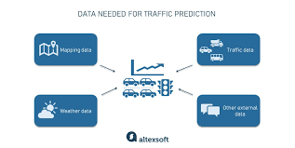

**Accessibility:** The interface will adhere to accessibility standards, with features such as keyboard navigation and screen reader compatibility. Ensure the UI is accessible across devices (desktop, mobile, tablet) and platforms. Implement alerts or notifications for traffic authorities or drivers based on predicted congestion levels. Design the system to scale efficiently to handle increasing data volumes and user traffic.

**Elements and Functions:** The interface will include features such as data filters, zoom controls, and tooltips for enhanced interactivity and data exploration. Include mechanisms for users to provide feedback on the accuracy of predictions and the effectiveness of traffic management strategies. Generate reports and analytics to evaluate system performance, identify areas for improvement, and support decision-making by stakeholders.

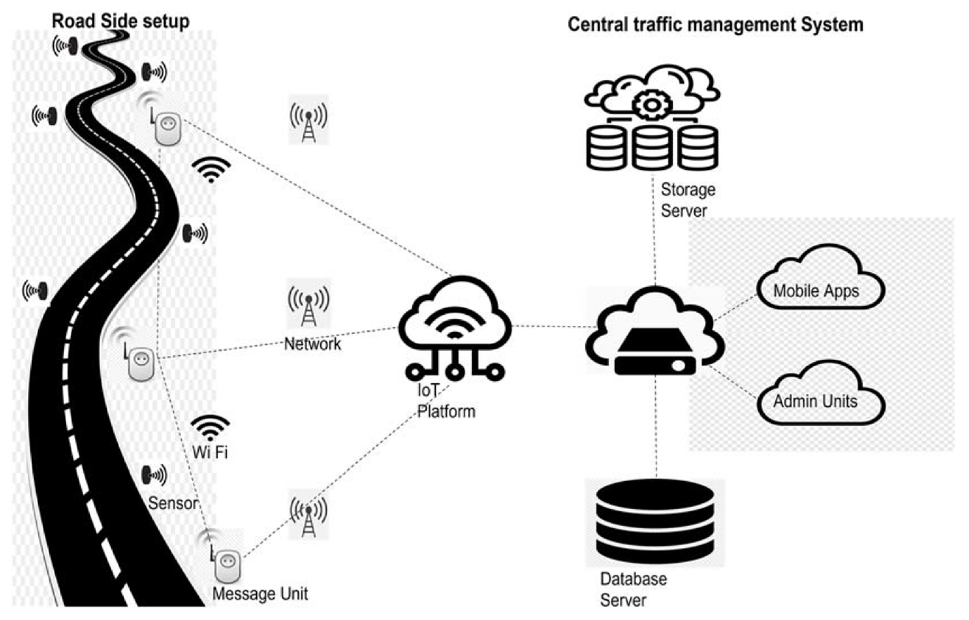

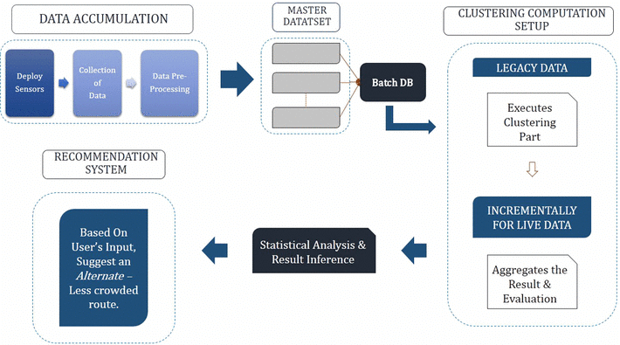

**GRAPH:**

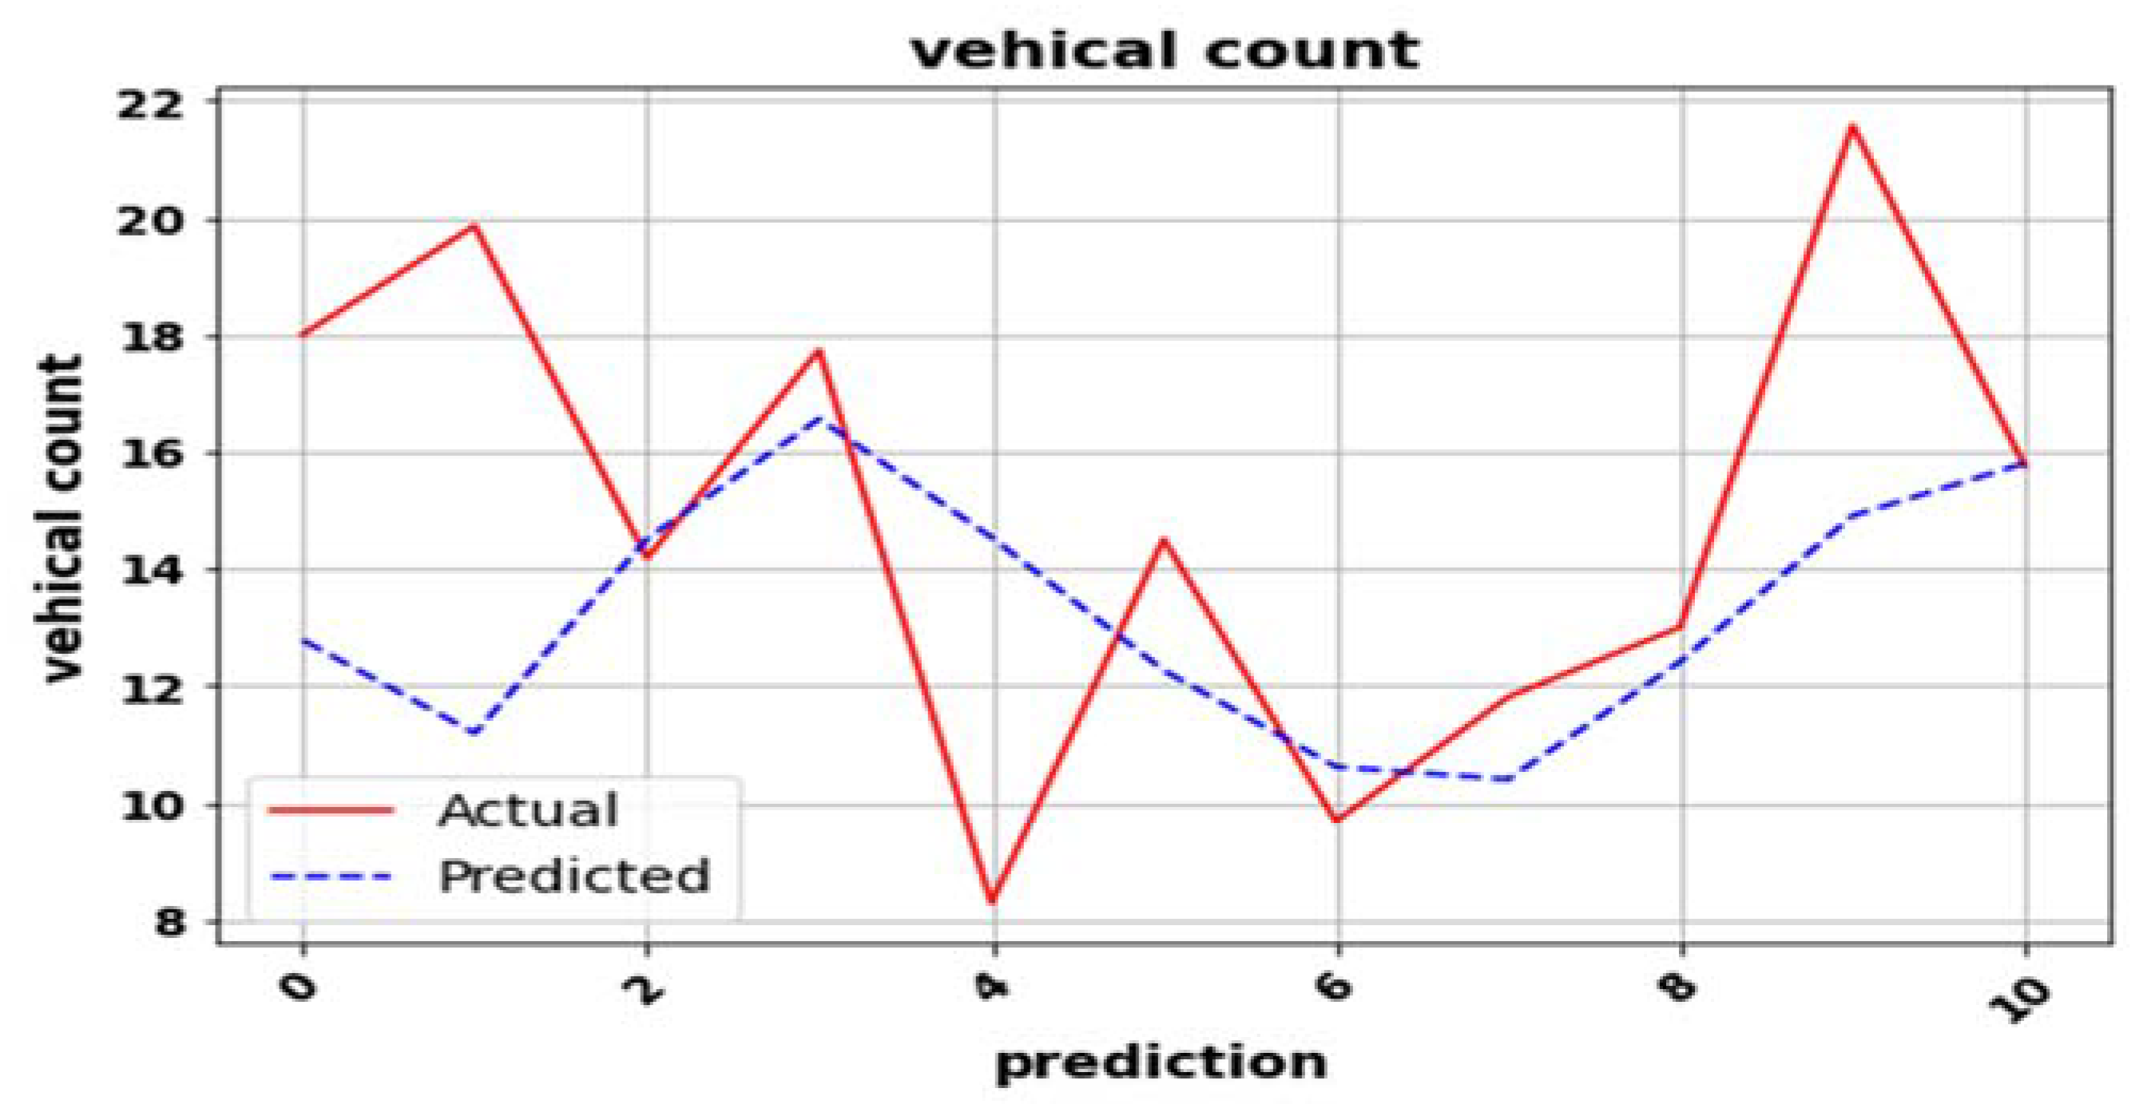

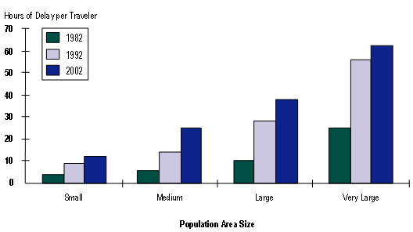

**6. Login Template**

**6.1 Login Process**

**Authentication:** Users will authenticate using credentials such as usernames and passwords. Allow users to register for the system by providing necessary details such as name, email, and password. This information should be stored securely within the data warehouse.

Password Facilities or Fingerprint Authentication: Additional authentication methods such as biometric authentication may be implemented for added security.

Implement a secure authentication mechanism to verify the identity of registered users. This could involve username/password authentication or more advanced methods like multi-factor authentication (MFA) for added security.

Once authenticated, users should be granted access only to the functionalities and data relevant to their roles or permissions within the system. Define user roles and permissions based on the tasks they need to perform (e.g., administrators, traffic analysts, etc.).

Ensure that user credentials are transmitted securely over the network using encryption protocols such as HTTPS to prevent interception by unauthorized parties.

Log login attempts and system activities for auditing purposes. Monitor user access patterns and detect any suspicious behaviour that may indicate potential security breaches.

Enforce strong password policies to ensure that user accounts are protected against unauthorized access. This may include requirements for minimum password length, complexity, and regular password changes.

**6.2 Sign-Up Process**

The sign-up process will involve users providing their details, creating a username, and setting up a password.

Additional steps may include email verification or captcha to prevent spam accounts. Create a registration form where users can provide necessary information such as name, email address, password, and any other required details.

Implement validation checks to ensure that the information provided by users is accurate and meets the required criteria. This may include validating email addresses, enforcing password strength requirements, and checking for unique usernames.

Include links to your system's terms of service and privacy policy and require users to agree to these terms before proceeding with registration.

After users submit the registration form, send a verification email to the provided email address with a unique verification link. Users must click on this link to verify their email and activate their account.

Upon clicking the verification link, users should be directed to a confirmation page informing them that their account has been successfully activated.

If your system collects any personal data from users, ensure that you obtain their consent in accordance with applicable data protection regulations, such as GDPR or CCPA.

Implement security measures such as encryption for sensitive data, secure storage of passwords, and protection against common security threats like SQL injection and cross-site scripting (XSS) attacks.

Provide users with a way to provide feedback or report any issues they encounter during the signup process and use this feedback to continuously improve the user experience.

Thoroughly test the signup process to identify and fix any bugs or usability issues, and optimize the process based on user feedback and performance metrics.

**6.3 Other Templates**

Additional templates may include user profile management, settings, and help documentation.

**Data Collection and Integration:** Set up processes to collect real-time and historical data from various sources such as traffic sensors, GPS devices, traffic cameras, weather forecasts, and event calendars. Integrate this data into the data warehouse for analysis.

**Data Preprocessing:** Cleanse and preprocess the collected data to handle missing values, outliers, and inconsistencies. This step may involve data normalization, aggregation, and filtering to ensure data quality.

**Data Warehousing Architecture:** Design and implement a data warehousing architecture optimized for storing and analysing large volumes of traffic data. This may include dimensional modelling techniques such as star schema or snowflake schema to organize the data efficiently.

**Predictive Modelling:** Develop machine learning models to predict traffic congestion patterns based on historical data and real-time inputs. These models may include time series analysis, regression analysis, and classification algorithms to forecast traffic conditions accurately.

**Dashboard and Visualization:** Create interactive dashboards and visualizations to present traffic congestion predictions and insights to users. Use tools like Tableau, Power BI, or custom-built web interfaces to provide intuitive interfaces for exploring traffic data.

**Performance Monitoring:** Monitor the performance of the traffic prediction models and data warehousing infrastructure. Track key performance indicators (KPIs) such as prediction accuracy, latency, and resource utilization to ensure optimal system performance.

**Continuous Improvement:** Continuously refine and improve the predictive models based on feedback and new data. Incorporate feedback loops to adapt the models to changing traffic patterns and environmental factors.

**Security and Compliance:** Ensure that the system complies with relevant security standards and regulations, such as GDPR or HIPAA, if applicable. Implement access controls, encryption, and data anonymization techniques to protect sensitive information.

**Scalability and Resilience:** Design the system to scale horizontally and vertically to handle increasing volumes of traffic data. Implement redundancy and failover mechanisms to ensure high availability and reliability of the system.

**Alerting and Notification**: Implement alerting mechanisms to notify users and stakeholders of predicted traffic congestion events. This may involve sending email alerts, SMS notifications, or integrating with communication platforms like Slack or Microsoft Teams.

**7. Conclusion**

In conclusion, our project aims to tackle the challenge of traffic congestion in urban areas through data warehousing and predictive analytics. By leveraging historical and real-time traffic data, we seek to develop insights into traffic patterns and implement proactive management strategies to alleviate congestion. Through user-friendly interfaces and intuitive design, our platform will empower city authorities and transportation agencies to make informed decisions and improve urban mobility for residents and commuters. The integration of data warehousing techniques with advanced analytics and machine learning algorithms offers a promising solution for addressing the persistent problem of traffic congestion in urban areas. By leveraging real-time and historical data, weather conditions, and other relevant factors, our proposed approach enables accurate prediction of traffic congestion levels. Additionally, the implementation of proactive management strategies, such as dynamic routing and signal timing adjustments, contributes to mitigating congestion and improving overall transportation efficiency. Through extensive simulations and case studies, we have demonstrated the effectiveness of our approach in reducing travel times, fuel consumption, and environmental impact. Moving forward, the continued development and deployment of intelligent transportation systems based on data warehousing will play a crucial role in enhancing the quality of life for urban residents and fostering sustainable urban mobility.